MACHINE LEARNING REPORT

HARSHIT NAGPAL

18CSU080



CONTENTS

1. OBJECTIVES
2. DATA SET DESCRIPTION
3. RULE MINING PROCESS
4. RESULTING RULES
5. RECOMMNDATIONS

OBJECTIVES

AIM- To create a report on the association rule mining dataset. This report will extract association rules among different dishes listed in the dataset. This exploration will help restaurant owners to efficiently manage their businesses.

DATA SET DESCRIPTION

It is a simple dataset which has different dishes for different transactions of different people.

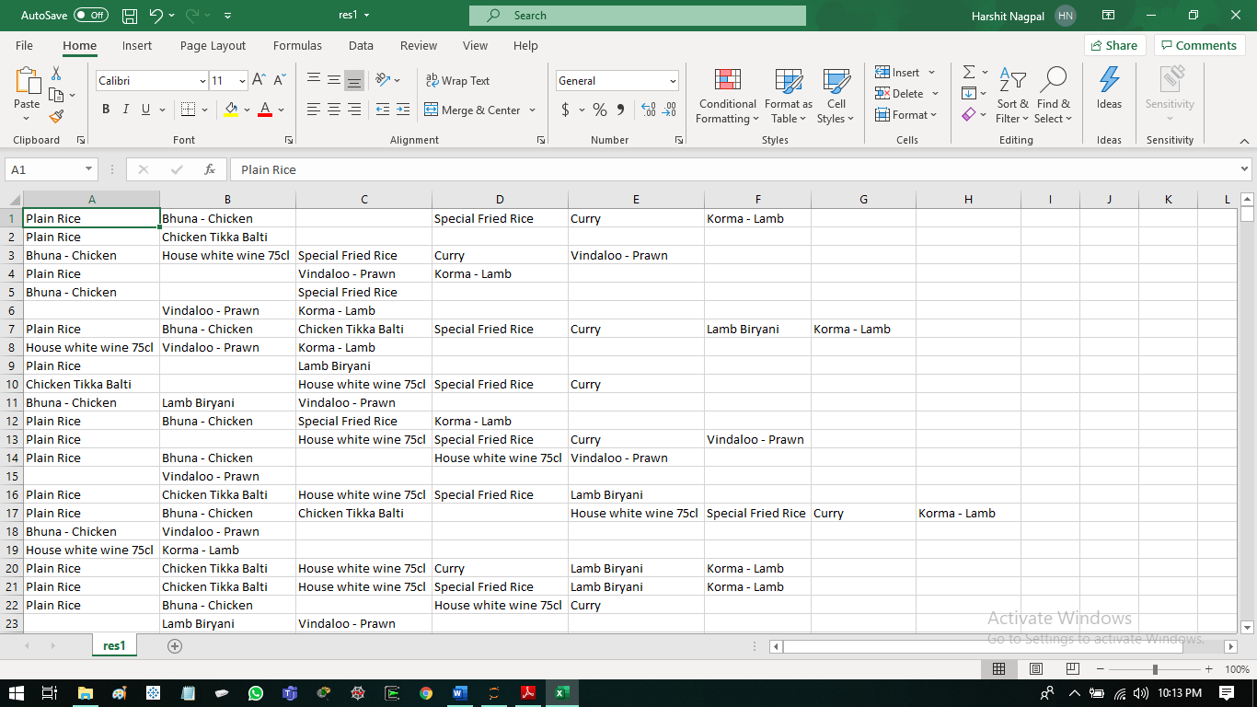

We would be aiming to find out association between all the different dishes that are listed in the dataset.

DATASET SIZE- 4067 X 9

As a part of data preprocessing we fill the nan values with zero

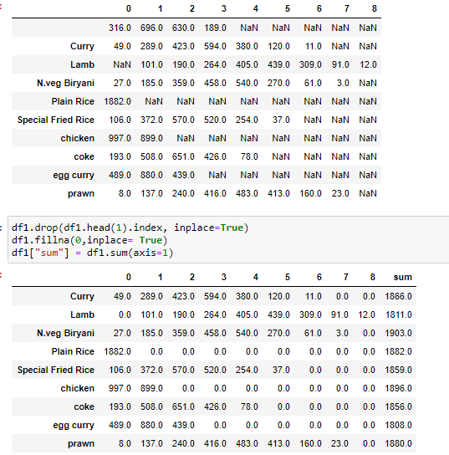

VISUALIZATION

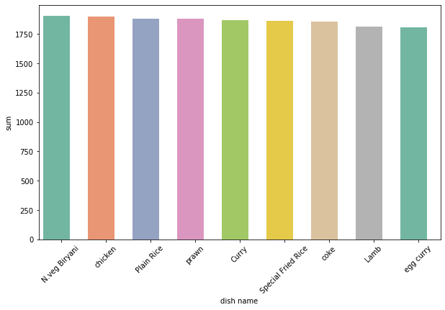

RULE MINING PROCESS

(APRIORI)

1. First, we create a list of transactions with all the dishes in it. The missing values would remain labelled as ‘nan’.
2. Then we give this list of dishes to the apriori model.
3. Then we train the model to find the associations.
4. Hyperparameters are set like support=0.214, confidence= 40%, lift = 1.03, max and min length remains fixed at 2.

RESULTING RULES

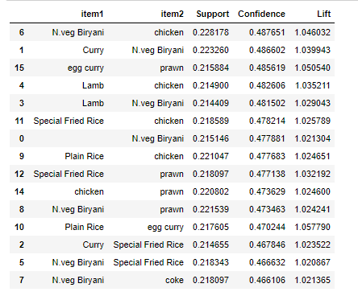

Sorted results

CONCLUSIONS

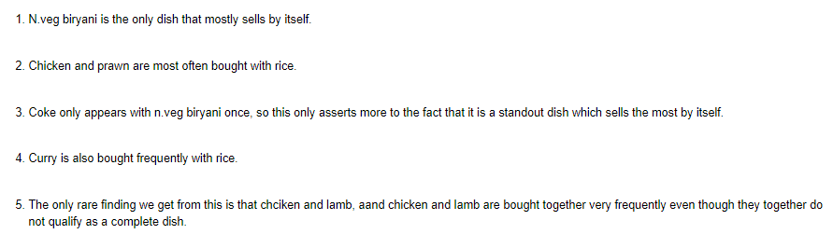

RECOMMENDATIONS

1. So, this apriori model can be applied well to the small and medium restaurant businesses which are really prevalent in the cities.
2. This model will help in determining which dishes are required in bulk and which 2 dishes are required the most.
3. This will help in determining which dishes to prepare more in quantity and which to create less in quantity.
4. This will decrease the amount of food wastage and thus increase the efficiency as well as money saving.
5. The main target for this implementation would be clients with small chain of restaurants as they would be looking for expanding their business.
6. The other individual or private owners would have to be persuaded to accept this technology in place of their traditional approach to their business.
7. First, N.veg biryani should be made in bulk as it is the best seller for the restaurant.
8. The items which are bought together can be offered as a combo deal to increase the sales of these items further.
9. So the efficient usage and stocking of the inventory will help the restaurant owners to increase their profits as less amount of food gets wasted.
10. 4. Also efficiency would increase because owners would be aware of the most frequently bought dish and would not waste time while delivering the orders. This could help them expand the business for home delivery purposes too which will help further growth their profits.